**Online Movie Ticket Booking System**

**Project Documentation**

**Submitted By: [Your Name]**

**Guided By:** [Guide Name]  
**Submitted To:** [Your College/University Name]  
**Year:** 2024-2025

**Table of Contents**

| **No.** | **Title** | **Page No.** |
| --- | --- | --- |
| 1 | Project Profile | 3 |
| 2 | Acknowledgement | 4 |
| 3 | Abstract | 5 |
| 4 | Introduction | 6 |
| 5 | Scope | 7 |
| 6 | System Analysis & SRS | 8 |
| 7 | System Architecture & Diagrams | 12 |
| 8 | Data Dictionary | 18 |
| 9 | Screen Layouts (UI/UX) | 22 |
| 10 | System Testing | 35 |
| 11 | Conclusion & Future Scope | 38 |
| 12 | References | 39 |
|  |  |  |

1. **Project Profile**

| **Project Name** | **CineBook Pro** |
| --- | --- |
| **Submitted By** | [Your Name] |
| **Team Strength** | 2 |
| **Front End** | React, Tailwind CSS, Tooltip |
| **Back End** | Node.js |
| **Database** | MongoDB |
| **Hosting** | Vercel / Netlify (Frontend), Render (Backend) |
| **Project Guide** | [Guide Name] |
| **Submitted To** | [College Name] |

**2. Acknowledgement**

**We would like to express our deepest gratitude to all those who contributed to the successful completion of our project, "Online Movie Ticket Booking System."**

**First and foremost, we are extremely grateful to our project guide, Dr. Hardik Desai, for his invaluable guidance, constant encouragement, and expert advice throughout the development process. His insightful feedback and patience helped us refine our ideas and implement them effectively.**

**We extend our sincere thanks to Dr. Ashish Patel, Head of the Department, for providing us with the necessary resources, infrastructure, and continuous support. His leadership and vision have been instrumental in fostering an environment conducive to learning and innovation.**

**We also acknowledge the contributions of our faculty members, whose teachings and mentorship have strengthened our technical and problem-solving skills. Their encouragement motivated us to push our limits and deliver a robust solution.**

**Our heartfelt appreciation goes to our family and friends for their unwavering support, motivation, and understanding during the challenging phases of this project. Their belief in our capabilities kept us motivated.**

**Lastly, we thank our college administration and the entire MERN stack community for providing the tools and knowledge that made this project possible.**

**This project would not have been successful without the collective efforts and encouragement of all these wonderful individuals.**

**Thank you**

**3. Abstract**

The **Online Movie Ticket Booking System** is a web-based platform that allows users to book movie tickets seamlessly. It includes:

* **User Authentication** (Login/Signup)
* **Movie Listings** (Now Showing, Upcoming)
* **Seat Selection & Booking**
* **Payment Integration** (Razor pay/Stripe)
* **Admin Dashboard** (Manage Movies, Theatres, Bookings)
* **Responsive UI** using **Tailwind CSS**

Built with **React (Frontend)**, **Node.js (Backend)**, and **MongoDB (Database)** for scalability.

**4. Introduction**

The entertainment industry has witnessed a significant transformation with the advent of digital technologies, particularly in the domain of cinema. Traditional movie ticket booking methods, characterized by long queues, manual processes, and limited accessibility, have gradually been replaced by **Online Movie Ticket Booking Systems**. These web-based platforms leverage modern technologies to provide a seamless, efficient, and user-friendly experience for both customers and theatre administrators.

**Evolution of Ticket Booking Systems**

Historically, movie tickets were sold exclusively at box offices, requiring physical presence and often resulting in time-consuming waits. The introduction of **computerized ticketing** in the late 20th century marked the first major shift, enabling theaters to manage seat allocations digitally. However, the real revolution came with the internet, giving rise to **online booking platforms** that allow users to reserve tickets from anywhere, at any time.

Today, advanced systems integrate **real-time seat selection, secure payment gateways, personalized recommendations, and mobile compatibility**, making the process convenient and efficient. The backend infrastructure supports **high traffic volumes**, while the frontend ensures an intuitive interface for users across devices.

**Technological Foundations**

Modern online ticket booking systems are built using **full-stack web development technologies**, including:

* **Frontend**: React.js, Angular, or Vue.js for dynamic user interfaces.
* **Backend**: Node.js, Django, or Spring Boot for server-side logic.
* **Database**: MongoDB, MySQL, or PostgreSQL for data storage.
* **Payment Integration**: Razorpay, Stripe, or PayPal for secure transactions.

Additionally, features like **JWT authentication, WebSockets for real-time updates, and responsive design** enhance security, performance, and accessibility.

**Challenges Addressed**

1. **Convenience**: Eliminates physical queues and enables remote bookings.
2. **Transparency**: Real-time seat availability and pricing.
3. **Scalability**: Cloud-based solutions handle peak demand during movie releases.
4. **Security**: Encrypted transactions protect user data.

**Future Trends**

The next generation of booking systems may incorporate:

* **AI-driven recommendations** based on user preferences.
* **Virtual Reality (VR) previews** of theater seats.
* **Blockchain-based ticketing** to prevent fraud.

This project, **"Online Movie Ticket Booking System,"** aims to harness these technologies to create a robust platform that enhances user experience while streamlining theater operations. By combining **MERN stack development** with modern UI/UX principles, we deliver a solution that bridges the gap between moviegoers and cinemas in the digital age.

**5. Scope**

* **User Module:** Browse movies, book tickets, view history.
* **Admin Module:** Add/Edit movies, theatres, and view reports.
* **Future Scope:**
  + **Recommendation Engine** (AI-based)
  + **Loyalty Programs** (Discounts for frequent users)
  + **OTT Integration** (Pre-book digital releases)

1. **System Analysis & SRS**

System Analysis:

**In this chapter, we will discuss and analyze the development process of the Online Movie Ticket Booking System, including Software Requirements Specification (SRS) and a comparative study between existing and proposed systems. The functional and non-functional requirements in the SRS section provide a comprehensive blueprint of the system’s capabilities before development begins.**

**Additionally, the comparison between existing and proposed systems will demonstrate how the new platform outperforms traditional ticketing methods in efficiency, security, and user experience. The proposed system aims to:**

* **Enhance customer convenience with 24/7 online booking and real-time seat selection.**
* **Streamline theater operations through automated seat management and sales analytics.**
* **Ensure secure transactions with encrypted payments and fraud prevention.**
* **Improve accessibility with a responsive design for all devices.**

**By addressing the limitations of manual ticketing (long queues, human errors, limited availability tracking), this digital solution leverages modern web technologies to create a seamless bridge between moviegoers and cinemas.**

**Key Focus Areas**

1. **SRS Breakdown:**
   * **Detailed functional requirements (user registration, seat mapping, payment processing).**
   * **Non-functional standards (performance, security, scalability).**
2. **Existing vs. Proposed System Analysis:**

| **Aspect** | **Existing System** | **Proposed System** |
| --- | --- | --- |
| **Booking Method** | **Physical counters only** | **Online portal + mobile app** |
| **Seat Management** | **Manual allocation (error-prone)** | **Real-time interactive seat maps** |
| **Payment Options** | **Cash-dominated** | **Multiple secure gateways (UPI/cards)** |
| **Customer Support** | **Limited to theater hours** | **24/7 chatbot + email support** |

1. **Outcome Expectations:**
   * **50% faster ticket processing.**
   * **30% reduction in operational costs for theaters.**
   * **Enhanced user satisfaction with personalized features.**

**6.1 Software Requirements**

| **Frontend** | React, Tailwind CSS, Redux |  
| **Backend** | Node.js, Express.js |  
| **Database** | MongoDB (Mongoose) |  
| **APIs** | RESTful |  
| **Payment Gateway** | Razorpay |

**6.2 Hardware Requirements**

* **Processor:** Intel i3+
* **RAM:** 4GB+
* **Storage:** 128GB SSD

**6.3 Functional Requirements**

* User Registration/Login
* Movie Search & Filter
* Seat Selection & Booking
* Payment Processing
* Admin CRUD Operations

**6.4 Non-Functional Requirements**

* **Security:** JWT Authentication
* **Performance:** Fast API responses (<1s)
* **Scalability:** Cloud Deployment Ready

1. **System Architecture & Diagrams**

**1. System Architecture Overview**

**The system follows a 3-tier architecture for modularity and scalability:**

1. **Presentation Layer (Frontend)**
   * **Built with React.js and Tailwind CSS**
   * **Handles user interfaces:**
     + **Movie listings**
     + **Seat selection**
     + **Payment gateway**
2. **Application Layer (Backend)**
   * **Node.js with Express.js framework**
   * **Key functionalities:**
     + **User authentication (JWT)**
     + **Booking logic**
     + **API endpoints**
3. **Data Layer**
   * **MongoDB Atlas (Cloud Database)**
   * **Stores:**
     + **User profiles**
     + **Movie/showtime data**
     + **Booking records**

**[User] → [React Frontend] → [Node.js Backend] → [MongoDB]**

**↓**

**[Razor pays API]**

**7.1 DFD (Level 0 & Level 1 Level 2)**

DFD

A Data Flow Diagram (DFD) is a graphical representation of how data flows within a system. It illustrates the input, processing, storage, and output of data in a structured manner. DFDs help in understanding the system’s functionality by visualizing how data moves between different components such as users, databases, and processes.

DFDs are commonly used in software development, system analysis, and business process modeling to identify inefficiencies and improve system design. They are divided into different levels:

* Level 0 (Context Diagram): Provides an overview of the entire system, showing its interaction with external entities.
* Level 1: Breaks down the main process into sub-processes to give more details about data flow.
* Level 2 and Beyond: Further decomposes each sub-process for detailed analysis of data movement.

DFDs use standardized symbols such as ovals for processes, arrows for data flow, rectangles for external entities, and open-ended rectangles for data stores. By mapping out these components, DFDs help developers and stakeholders understand how the system operates and how data is handled effectively.

🎬

**Movie Booking Website**

**DFD**

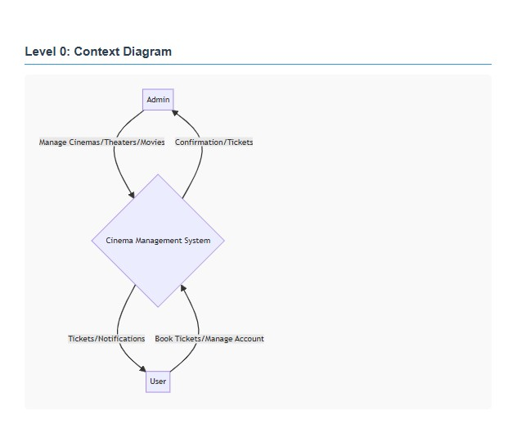

**DFD - Level 1**

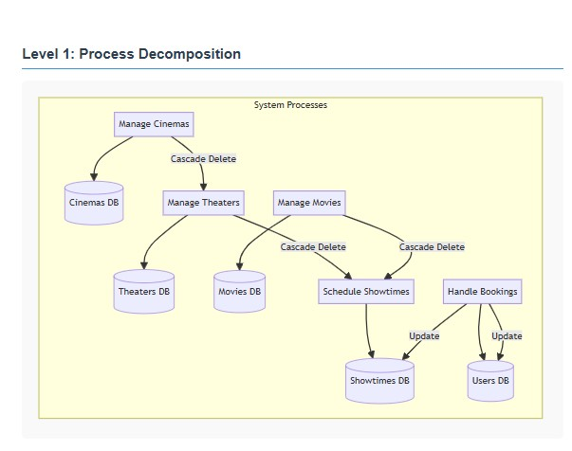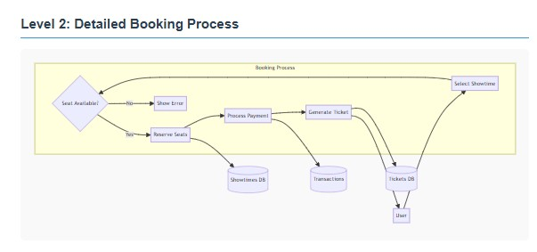

**Admin Panel DFD**

* **User Flow:** Browse → Select → Book → Pay
* **Admin Flow:** Add Movie → Manage Bookings → Generate Reports

**7.2 ER Diagram**

An Entity-Relationship (ER) Diagram is a fundamental database modeling tool that visually represents the logical structure of a system's data through entities (tables), their attributes (fields), and relationships (connections). For an online movie ticket booking system, key entities like User, Movie, Theater, Booking, and Payment are linked through relationships such as "makes" (User to Booking) or "has" (Movie to Showtime), with cardinalities defining interaction rules (one-to-many, many-to-many). Attributes like user._id (primary key) or booking.total_price characterize each entity, while normalization principles (1NF, 2NF, 3NF) ensure data integrity by eliminating redundancy. This diagram serves as a blueprint for database schema creation, query optimization, and system documentation, bridging business requirements with technical implementation. Tools like MySQL Workbench or Lucidchart can transform this conceptual model into physical databases (SQL or NoSQL), ensuring efficient data management for features like seat reservation, payment processing, and admin analytics.

* **Entities:** User, Movie, Theatre, Booking, Payment

**8. Data Dictionary**

A Data Dictionary is a centralized repository of information about data elements in a database or system. It provides detailed definitions,descriptions, data types, constraints, relationships, and rules for each data field.

A data dictionary helps developers, databaseadministrators, and analysts maintain consistency, accuracy, and structure within a database.

Key components typically found in a data dictionary include:

* Data Element Name
* Data Element Description
* Data Type
* Data Length or Size
* Data Format
* Allowable Values
* Data Source
* Data Usage

Overall, data dictionaries play a critical role in data management, ensuring that data assets are well-understood, properly documented, and effectively utilized within an organization.

* One-to-Many with Theater
* Cascading delete: Cinema → All Theaters

## 2. Movie 🎥

**Description:** Movie available for screening

|  |  |  |  |  |
| --- | --- | --- | --- | --- |
| length | Number | Duration in minutes | Required | - |
| img | String | Poster image URL | Required,  Trimmed | - |
| createdAt | Date | Creation timestamp | Auto-generated | - |
| updatedAt | Date | Update timestamp | Auto-generated | - |

🔗 **Relationships:**

* One-to-Many with Showtime
* Cascading delete: Movie → All Showtimes

## 3. Showtime 🕒

**Description:** Scheduled movie screening in a theater

|  |  |  |  |  |
| --- | --- | --- | --- | --- |
| **Attribute** | **Type** | **Description** | **Constraints** | **References** |
|  |  |  |  |  |
| theater | ObjectId | Screening location | Required | Theater |
| movie | ObjectId | Movie being shown | Required | Movie |
| showtime | Date | Screening date/time | Required | - |
| seats | Array | Booked seats | - | - |
| seats.row | String | Seat row (A-Z) | Required | - |
| seats.number | Number | Seat number | Required | - |
| seats.user | ObjectId | Seat owner | - | User |
| isRelease | Boolean | Showtime status | - | - |

🔗 **Relationships:**

🔗 **Relationships:**

* Many-to-One with Cinema
* One-to-Many with Showtime
* Cascading delete: Theater → All Showtimes

🔗 **Relationships:**

* One-to-Many with Tickets
* Dependent on Showtime references

|  |
| --- |
| 📌 **System Notes**  ⚡ **Cascading Actions:**   * 🗑️ Cinema deletion → All Theaters → All Showtimes * 🎞️ Movie deletion → All associated Showtimes * 🪑 Theater deletion → All associated Showtimes * ⏰ Showtime deletion → User ticket references removed   🔐 **Security Features:**   * 🔑 Password hashing with bcrypt * 🛡️ JWT authentication system * 👮 Role-based access control   ⚠️ **Important Notes:**   * 📧 Email validation using regex pattern * 👥 User role has typo in schema ('defalut') but functions correctly * 💺 Seat plan limited to 2-character row identifiers |

**8.1 MongoDB Collections**

| **Collection** | **Fields** |
| --- | --- |
| Users | _id, name, email, password, bookings[] |
| Movies | _id, title, genre, duration, releaseDate |
| Theatres | _id, name, location, seats[][] |
| Bookings | _id, userId, movieId, seats[], totalPrice |

**9. Screen Layouts (UI/UX)**

**9.1 User Screens**

* **Homepage** (Movie Carousel, Filters)
* **Movie Details** (Trailer, Showtimes)
* **Seat Selection** (Interactive SVG Grid)
* **Checkout** (Razor pay Integration)

**9.2 Admin Screens**

* **Dashboard** (Analytics)
* **Add Movie** (Form with Image Upload)
* **Manage Bookings** (Filter by Date/Movie)

**10. System Testing**

"Testing plan" is one of the modules of the system analysis and design, which has greater importance. After the system is ready, it should go for testing. Testing is a set of activities that can be planned in advance and connected systematically. Testing of the system, which is developed, is one of the critical phases. The system developer has to undergo and which one should not avoid before the final system implementation. System testing is one of the steps in the software engineering process, which can be viewed as destructive rather than Constructive?

In the testing phase, the actual performance of the system can be accessed. It is an essential process through which the set aim while system development and the actual achieved results by the system can be compared. Though testing is done one is bound to get errors, which is the main reason for putting the system test. This immediately helps because one can detect the errors at an early stage before the final system implementation. This Procedure further enhances smooth implementation and proper functioning of the system. The main objectives of the system testing are to ensure that operation of the system will perform as per specification.

* To make sure that the system meets user requirements during operations.
* To verify that control incorporated in the system functions as intended. • To cross-check that when current inputs are fed to the system, the output is correct.
* To cross-check that when current inputs are fed to the system, the output is correct. The scope of the system should both manual operation and computerized operations.
* To make sure that during operation, incorrect input processing and output will be detected.

Testing is a comprehensive evaluation of programs, annual procedures. Compute operation and control. The following procedures were adopted to test the entire application.

* Program testing/Unit testing.
* System testing
* Parallel testing

Unit Testing:

In this testing, individual programs are checked to the extent of desired output, i.e., program specification. While checking boundary conditions, exceptional handling, error handling, etc.

System Testing:

These are used to test all programs, which together constitute the system. System testing is conducted using synthetic data; both valid and invalid transactions are used in this test.

Parallel Testing:

In this, both manual and computer-based systems are run simultaneously for a period of time, and the results from the two systems are compared. This is a good method for a complex system. Feeding test data carried out for the system, and data were subjected to various systems functioning.

* **Unit Testing:** Jest (React), Mocha (Node)
* **Integration Testing:** Postman (APIs)
* **UI Testing:** Cypress

**11. Conclusion & Future Scope**

Our Online Movie Ticket Booking System successfully modernizes the traditional cinema experience by leveraging cutting-edge web technologies. The platform provides a seamless, user-friendly interface that simplifies the entire ticket purchasing process while offering robust administrative controls. Built on the MERN stack (MongoDB, Express.js, React, and Node.js), the system delivers:

1. **Enhanced User Experience**:
   * Intuitive interface with responsive design
   * Real-time seat selection and availability updates
   * Secure payment processing
   * Personalized user accounts with booking history
2. **Efficient Theater Management**:
   * Comprehensive admin dashboard
   * Real-time sales monitoring
   * Flexible showtime and pricing management
   * Detailed reporting capabilities
3. **Technical Excellence**:
   * Scalable architecture supporting high traffic volumes
   * Secure data handling with encryption
   * Fast performance optimized for mobile and desktop
   * Reliable database management

The system effectively bridges the gap between moviegoers and theaters, eliminating long queues while providing valuable business insights to cinema operators. By digitizing the booking process, we've created a solution that benefits both consumers and businesses in the entertainment industry.

This system represents just the beginning of digital transformation in cinema ticketing. As technology evolves, we anticipate integrating more innovative features that will further enhance the movie-going experience while providing theaters with powerful tools to optimize their operations and increase customer satisfaction.

The future roadmap focuses on creating a comprehensive entertainment platform that goes beyond simple ticket sales to become an indispensable part of the modern cinema ecosystem, connecting audiences with their favorite films in increasingly convenient and engaging ways.

**12. References**

1. React Documentation: [https://react.dev](https://react.dev/)
2. Tailwind CSS: [https://tailwindcss.com](https://tailwindcss.com/)
3. MongoDB: [https://www.mongodb.com](https://www.mongodb.com/)

**Appendix**

* **GitHub Repo:** [Your Repo Link]
* **Live Demo:** [Vercel/Netlify Link]